Multiple Choice
1)
Which statements about bpmn.io are true?
bpmn.io comes with a Java API that can be used to render BPMN models.
bpmn.io is available for Enterprise customers only.
bpmn.io is the basis for the supported Camunda Modeler.
bpmn.io is a popular Community Extension for Camunda BPM.
bpmn.io can be used by developers to build their own BPMN modeler.
Multiple Choice
2)
What are the correct ways to represent a Date and Time object in FEEL?
date and time(“yyyy-MM-dd'T'HH:mm:ss”)
datetime(“yyyy-MM-dd'T'HH:mm:ss”)
dateTime(yyyy-MM-dd'T'HH:mm:ss)
dateTime(“yyyy-MM-dd'T'HH:mm:ss”)
date and time(yyyy-MM-dd'T'HH:mm:ss)

Multiple Choice
3)
Which of the following statements about attached boundary events is correct?

Attached timer events can only be interrupting, i.e. there is no non-interrupting timer event in the BPMN 2.0 standard
Events can be attached to all types of activities including tasks, sub-processes and call activities.
Attached message throw events can be used to send a message from a call activity to the parent process.
Attached error and escalation events always interrupt the ongoing activity that they are attached to.
Multiple Choice
4)
When would you recommend a Standalone Remote Engine?
If I have only Java Delegates
If I have to care about transactional service invocation
If I use a programming language not running on a JVM
If I have no control over the containers hosting the delegate code
Multiple Choice
5)
Which of the following is not possible with Camunda's Spin API?
Reading and Writing XML
Reading and Writing JSON
Querying and Mapping XML
Querying and Mapping JSON
Directly Converting JSON to XML
Multiple Choice
6)
What must you be aware of if you have two parallel receive tasks?
Correlate the message with a process variable.
Correlate the message with a local variable.
Correlate the message with a business key.
Correlation is not possible due to the global scope of variables.
Multiple Choice
7)
Where can you use forms in a BPMN diagram?
User tasks only
User tasks and start events
Start events, user tasks and end events
User tasks and receive tasks
Multiple Choice
8)
Which of these features are only available in the EE version of Camunda?
Process Definition Heatmap
Process Model Previews
Incident Overview Page
Bulk Retry and Bulk Cancel
Process Instance Modification
Multiple Choice
9)
What are the characteristics of generated task forms?
They can be built with the Camunda modeler.
They are a feature complete task builder.
Writing HTML is not required.
They can show only primitive process variables.
Multiple Choice
10)
Which statements about multi tenancy are true?
The LDAP Identity Service doesn't support tenants.
Tenant-specific dedicated engines should be preferred over tenant identifiers in scenarios with a high number of tenants that produce only a small amount of data.
Users who are a member of the group camunda-admin can access the data of all tenants, even if they don’t belong to the tenants.
Camunda doesn't support multi-tenancy at all.
Multiple Choice
11)
Which are not operators for the Collect Hit Policy?
Count
Avg
Max
Min
Multiple Choice
12)
Which taskQuery must be used to build a list of tasks assigned to John?
taskService.createTaskQuery().taskCandidateUser("john").list();
taskService.createTaskQuery().taskCandidateGroup("john").list();
taskService.createTaskQuery().taskAssignee("john").list();
taskService.createTaskQuery().taskCandidateAssignee("john").list();
Multiple Choice
13)
How are process variables set via the process engine API?
Only as a string
As a map of objects
As a single object
Only as a primitive types
Multiple Choice
14)
What can happen to running instances of a process when a new version of that process is deployed?
They may not be affected and continue running on the version they were started on.
They could be migrated to the new version using Cockpit or the engine API.
They could all be cancelled and the original process definition removed.
By default, they will automatically continue on the new version as soon as it gets deployed.
All of the above.
Multiple Choice
15)
When do you have to deal with message correlation at the activity level rather than at the process level?
If you have a multi instance receive task
If you have two receive tasks in a sequence
If you have more than one receive task after a parallel gateway
If you use a message event after an event based gateway
Multiple Choice
16)
Which of these is not a valid FEEL data-type?
Number
Char
Boolean
Date
String
Multiple Choice
17)
How is a process participant most likely to interact with a deployed process?
Using Camunda Tasklist
Using Camunda Web Modeler
Using Camunda Admin
Using Camunda's REST API
Multiple Choice
18)
What is the most suitable Hit Policy for the table shown?

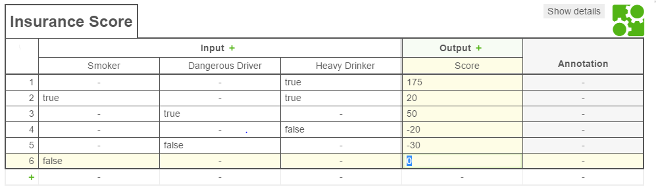
Any
Collect
Unique
Rule Order
First
Multiple Choice
19)
How many errors regarding naming conventions can you find in the following model?
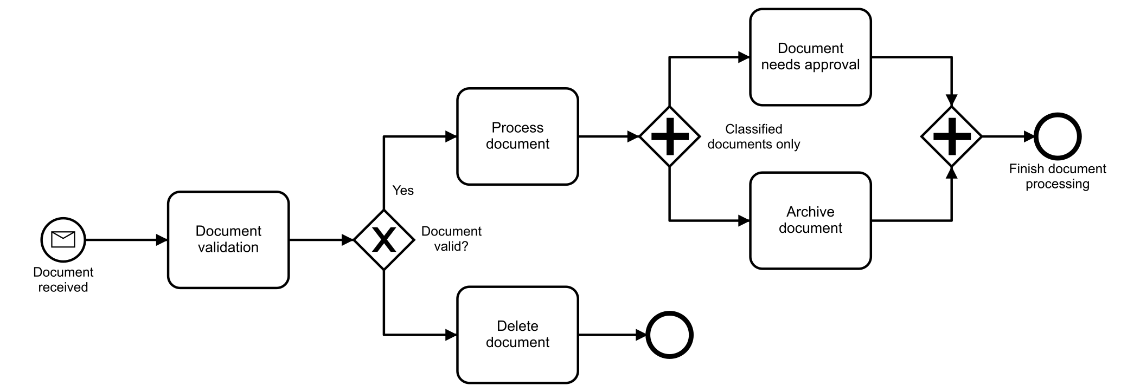
3
4
5
6
Multiple Choice
20)
In Camunda BPM, how would the process engineer convert the process diagram from the process analyst into an executable format?
No conversion is required
By using the Camunda BPEL-Converter Web Application
By manually converting it to BPEL
By using the Camunda Modeler's integrated converter
Multiple Choice
21)
How are process definitions versioned by the process engine?
They get a unique process definition ID and no further information.
They get an increasing version number.
There is only one active process definition in the engine.
They must be re-named in order to be versioned by the engine.
Multiple Choice
22)
Which feature(s) does Optimize NOT provide?
Reporting
Process automation monitoring
Process deployment
Process instance modification
Multiple Choice
23)
In which situations is the REST API best suited to use?
For JavaScript applications that communicate over a network
For Java delegates that are implemented as service tasks
For Java Server Pages deployed on the same container
For accessing processes from mobile applications
Multiple Choice
24)
Which statements about start events are correct according to the BPMN 2.0 standard?
A process can have more than one none start events.
A process can have one or more message start events.
A process can have one or more signal start events.
A process must have at least one start event.
Multiple Choice
25)
Business-IT Alignment is particularly easy to maintain with Camunda BPM for what fundamental reason?
There is no need for IT people to get involved in process creation.Camunda BPM operates as a zero-code platform and so there is no need for developers.Developers can easily re-create Business Models in XML for execution.BPEL can be used to make models easy to understand by both Business and IT.The same BPMN 2.0 models created by the Business can be made executable by the IT.
Multiple Choice
26)
Please complete the following sentence: The source code of the Camunda BPM engine...
is exclusively granted to enterprise customers.
may not be modified by anyone except camunda engineers.
is openly available.
is always bug free.
Multiple Choice
27)
Which forms can be used in the Camunda Tasklist?
Only Embedded Task Forms and Generic Task Forms
Automatic Task Forms, External Task Forms, Generated Task Forms, Generic Task Forms
Embedded Task forms, External Task Forms, Generated Task Forms, Generic Task Forms
External Task Forms, Generated Task Forms, Generic Task Forms, Specialized Task Forms
Multiple Choice
28)
What are the main reasons for using embedded sub processes in a process model?
To build reusable components
To make the process diagram more complicated
To use attached boundary events
To use multi instance markers
Multiple Choice
29)
What file is used as a deployment descriptor for process applications?
Bpm-platform.xml
Persistence.xml
Beans.xml
processes.xml
Multiple Choice
30)
How long does the following process instance take to finish?
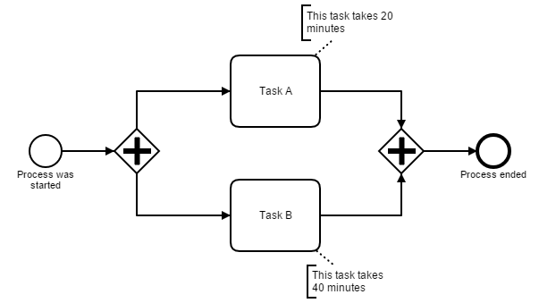
20 minutes
40 minutes
60 minutes
Either 20 or 40 minutes, depending on which task is executed.
Multiple Choice
31)
Select the correct answers. In a collaboration...
each pool represents an individual process.
processes can be started by incoming messages.
messages are exchanged by participants within pools.
collapsed pools can be used to model communication with third parties.
Multiple Choice
32)
In Tasklist, what are filters used for?
To create tasks for a user
To show the tasks for a user based on specific criteria
To help create authorizations for a given task
To help assign multiple tasks to a given user
Multiple Choice
33)
Which statements about script tasks are correct?
You have to add a script format.
The script can not access process variables.
There are no special keywords for script tasks.
The script can be an external file.
Multiple Choice
34)
What method is suggested to be used to test a decision table?
dmnEngine.evaluate (decision, variables)
dmnEngine.evaluateTable(decision, variables, version)
dmnEngine.evaluateDecisionTable(decision, variables, version)
dmnEngine.evaluateDecisionTable(decision, variables)
dmnEngine.evaluate(decision, variables, version)
Multiple Choice
35)
Which of the following approaches can be used to display a BPMN diagram in a custom front end application?
Use the Model API in combination with a picture of the process.
Use the Camunda UI builder to integrate a process diagram in custom forms at design time.
Use the Camunda Forms SDK to render a process diagram from the BPMN XML.
Use bpmn.io to render and annotate a process diagram from the BPMN XML.
Multiple Choice
36)
As a called process is evaluated at the moment when the token arrives at the call activity and this can be months away from the deployment, how can you influence the selected version of the called process?
Deploy the called process just before the token arrives in the call activity.
Specify the version as 'deployment' in the called process.
Specify the binding as 'deployment' in the call activity.
It is not possible to influence the version of the called process.
Multiple Choice
37)
How does a deployed process application WAR connect to the shared process engine?
A class has to call runtimeService.startProcessApplication().
A class has to start the process application manually.
A class with the annotation @ProcessApplication registers at the process engine.
No special class is needed.
Multiple Choice
38)
Where can an execution listener be invoked?
While a service task is being invoked
Before entering a service task
When a user task gets assigned
When a process instance is ended
Multiple Choice
39)
If you want to change how Camunda's Spin API handles specific data formats, what is the best way of accomplishing it?
Updating the project and sending a pull request to Camunda
Upgrade to the enterprise version where Spin has many additional data formats
Create a custom implementation of the DataFormatConfigurator
Use a 3rd party conversion API
Multiple Choice
40)
What would happen if the Result Variable field was left empty in a Business Rule Task of a BPMN model which called a DMN table?
Nothing, the engine would continue without the result.
The process would fail to deploy.A null pointer exception is raised.
The engine would hang – waiting for a variable to be returned.
The modeler would create a warning at design time.
Multiple Choice
41)
What are the benefits of using Delegate Expressions over Java classes?
Tight coupling of Java code and process definition
Loose coupling of process definition and Java code
You don't need to write Java code
Mocks are easily possible in JUnit tests
Multiple Choice
42)
What are the advantages of using the camunda-bpm-assert library?
You can write BPMN-specific assertions.
You can generate tests.
You can use a fluent API for assertions.
You can get information about the model via an assertion.
Multiple Choice
43)
What are the required parameters for a process model to call another process via a Call Activity?
The process definition key and the engine name of the called process
Only the process definition key of the called process
The process definition key and the version of the called process
The process instance ID of the called process
Multiple Choice
44)
Which of the following statements about gateways are correct?
Inclusive gateways cannot be used to merge incoming sequence flows.
Exclusive gateways invoke a decision to determine the outgoing sequence flow.
Parallel gateways produce additional tokens to split the incoming sequence flow into multiple outgoing sequence flows.
Inclusive gateways can be replaced by a combination of exclusive and parallel gateways.
Multiple Choice
45)
According to the BPMN 2.0 standard, what are differences between the message and signal event?
The signal can have zero recipients, a message must have exactly one.
Both are interchangeable
The message can be received by more than one process instance, the signal cannot.
The signal can be picked up by the process instance that sent it, messages cannot.
Multiple Choice
46)
Camunda is often deployed to supported containers as a standalone Web Application. What deployment type does usually not follow that pattern?
Embedded Engine
Remote Engine
Shared Engine
Standalone Engine
All of the above
Multiple Choice
47)
Why should you use a process engine in your software project?
Because different versions of a modeled process can be handled.
Because a process engine is intended to hide complexity inside a "black box".
Because the process is hidden in the code otherwise.
Because a process engine has features that are hard to implement independently.
Multiple Choice
48)
Where can scripting be used in Camunda BPM?
To complete a user task
At a point where you want to define a payload with a template
To evaluate the conditions of sequence flows
To start a process instance
To perform a script task
Multiple Choice
49)
Which are valid history levels in Camunda BPM?
None
All
Full
trailvariables
Multiple Choice
50)
Camunda Spin is used to help when working on complex objects. How does it help?
It offers an API to serialize objects into JSON.
It offers an API to serialize objects into XML.
It offers a method of sending SOAP calls with non-primitive payloads.
It offers a method of sending REST calls with non-primitive payloads.
None of the above.
Multiple Choice
51)
Which of the following shows an end event?

Multiple Choice
52)How can you integrate existing Spring components into your process application?
Deploy the process diagram with Spring
Call named beans in expressions
Use the @Transaction annotation
Inject the process engine and services into your components
Multiple Choice
53)
According to the task lifecycle how can you give delegated tasks back to the owner?
Assign it to the user
Delegate the task to the owner
Resolve the task
Unclaim the task
Multiple Choice
54)
Given that an error occurred in task three after five seconds, the process instance will be finished after 25 seconds.
Choose the correct end event which represents this scenario.

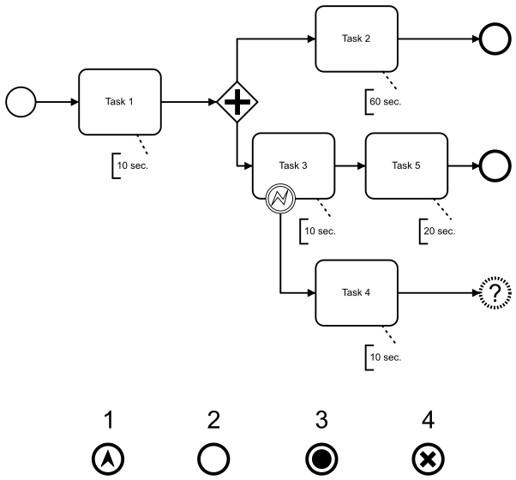

Multiple Choice
55)
Which task types can be implemented and used within Camunda for semi- or fully automated steps?
Business Rule Task
Undefined Task
User Task
Manual Task
Receive Task
Multiple Choice
56)
Which of the following statements about pools and lanes are correct?
A pool contains lanes which represent sub-units of that particular pool.
All flow elements, including tasks, gateways and events, are executed by the participant of the lane where the element resides.
Tasks can spread across lanes to describe that multiple participants perform an activity together.
Pools and lanes can describe responsibilities of single persons, groups, roles or technical systems.
Multiple Choice
57)
Which of the following models are wrong?
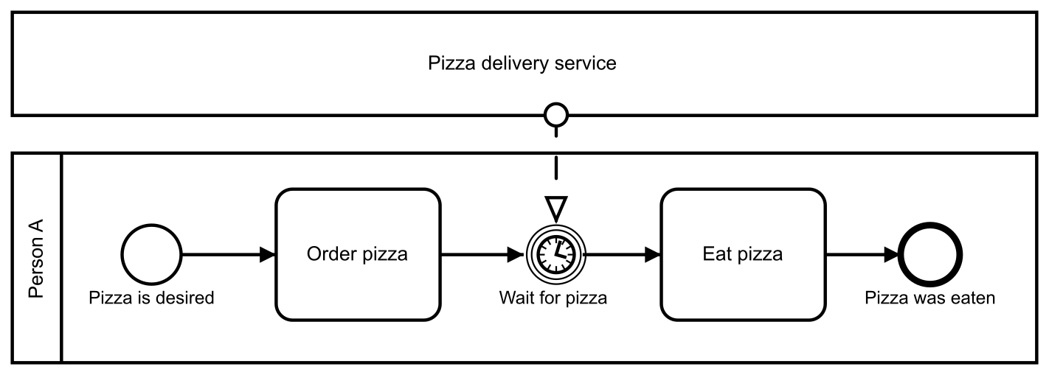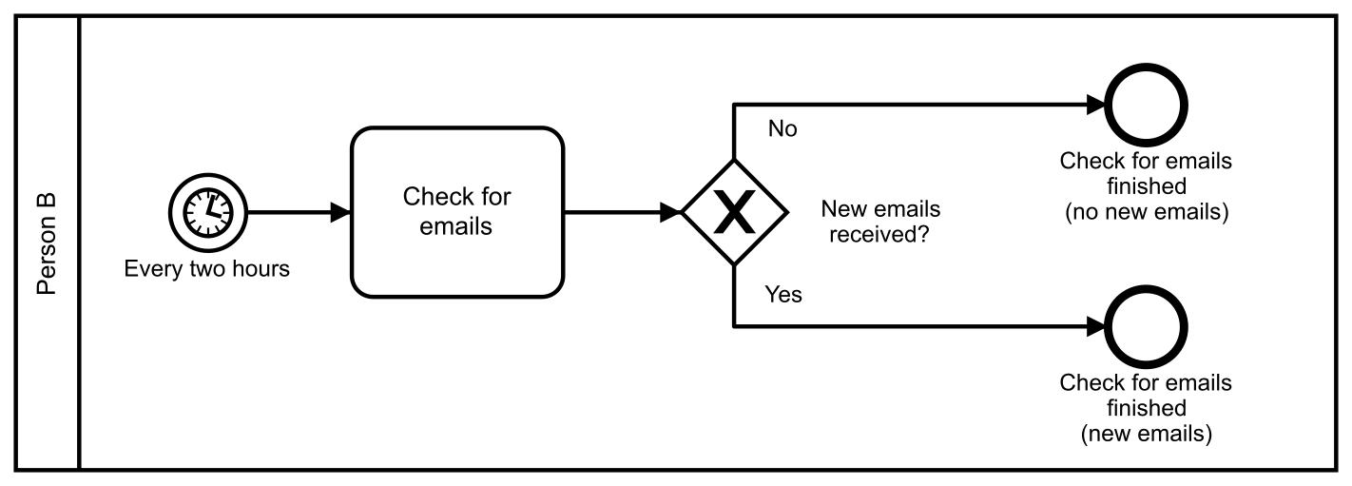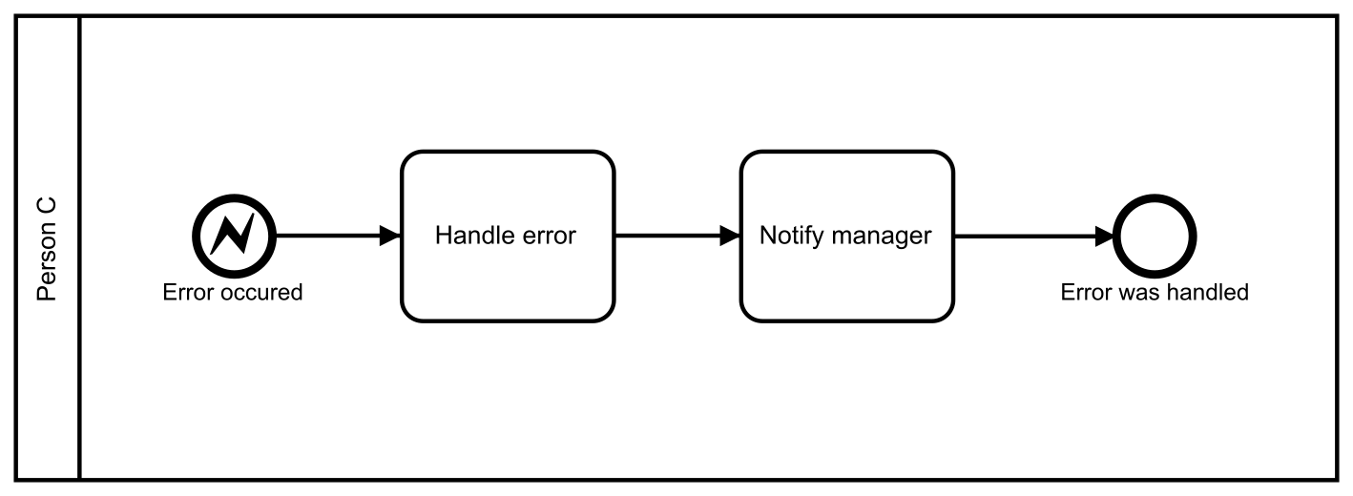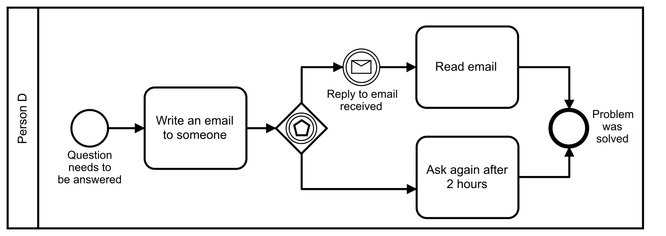
Multiple Choice
58)
Which of the statements below are true of a "Strategic Process Model"?
A strategic model represents the lowest level of abstraction for a given process.
A strategic model represents the highest level of abstraction for a given process.
A strategic model should never be created with the intention of executing it.
A strategic model should only contain human tasks.
A strategic model is intended to be understood by anyone - even if they don't know BPMN 2.0.
Multiple Choice
59)
Which of the following symbols is not part of BPMN?

Multiple Choice
60)
Which artifacts are stored in the database with a Camunda deployment?
Java delegates
All BPMN, DMN and CMMN diagrams
Only task forms
No artifacts are deployed to the Camunda database
Multiple Choice
61)
When does the process engine store the history values if the most detailed history level is set?
Only after the process instance is ended
After a task is completed
Runtime data is copied to the history in intervals
During the same database transaction as the runtime values
Multiple Choice
62)
Which of the statements below are true regarding Camunda BPM clusters?
Camunda can only cluster in homogeneous clusters (process applications deployed on all nodes).
Camunda can only cluster in heterogeneous clusters (process applications deployed only to a part of the nodes).
Camunda can cluster in homogeneous and heterogeneous clusters.
Camunda clusters can share the same Job Executor.
Camunda clustering can be set up by changing the Process Engine configuration.
Multiple Choice
63)
What happens if you deploy the process application with Java delegates and process definitions to the application server?
The Java classes are saved in the database.
The process models are added to the classpath.
The process models are saved in the database.
The Java classes are versioned.
Multiple Choice
64)
Which statements about Service Tasks are correct?
A Service Task calls a class implementing the task listener interface.
A Service Task can invoke a bean method.
A Service Task calls a class implementing the service task listener interface.
A Service Task calls a class implementing the JavaDelegate interface.
A Service Task can be handled by an external system.
Multiple Choice
65)
After an analyst has designed a BPMN process in the Camunda modeler, what activity is required before it can be executed?
The model needs to be transformed manually to executable XML.
The model needs to be exported to BPMN 2.0 and imported into the Eclipse Modeler.
A developer needs to re-create the model using the "executable symbol set".
A developer needs to add execution properties to the same XML.
Nothing is required - any model created in the Camunda modeler contains all the required executable properties.
Multiple Choice
66)
What is involved in human task management?
Ensure the right users get tasks they should be assigned to
Make it easy for users to find their assigned tasks
Ensure that service tasks perform calls to the correct service
Ensuring tasks are completed on time
Multiple Choice
67)
Please select one or more answers that would complete the following sentence:
Business-IT-Alignment...
can never be achieved.
needs readable process diagrams.
needs executable process diagrams.
is only possible when business analysts work with Eclipse.
Multiple Choice
68)
Which of these is required in order to cluster two or more Camunda Process Engines?
All engines must point to the same database.
The process engine must have been told about the existence of every other process engine.
All engines must be deployed to the same application server.
Cockpit and Tasklist must be put into "Cluster Mode".
All engines must share the same session information.
Multiple Choice
69)
Which of the following symbols shows a parallel gateway?

Multiple Choice
70)
Mark the correct answers:
Event sub-processes ...
cannot be triggered by none start events.
can be interrupting and non-interrupting to the parent process.
can be added at the process level or any sub-process level.
can be used to model semi-structured process flows.
Multiple Choice
71)
What are valid setups to achieve multi-tenancy with Camunda?
Shared engine with tenant identifiers on a shared database
Shared engine with tenant identifiers and a separate database schema for each tenant
One engine per tenant with a separate database schema for each tenant
One engine per tenant with a separate database for each tenant
Multiple Choice
72)
How does the engine know when to create a new version of a given process?
The "DeployNewVersion" method is invoked.
When the engine is restarted, it looks for new deployments and will create new versions for any deployments found.
If the BPMN XML has changed for a process key already deployed by default a new version is created.
The old version must be marked as "deprecated", after that any new deployments will be versioned.
All of the above.
Multiple Choice
73)
Select the option that is equivalent to the following process:
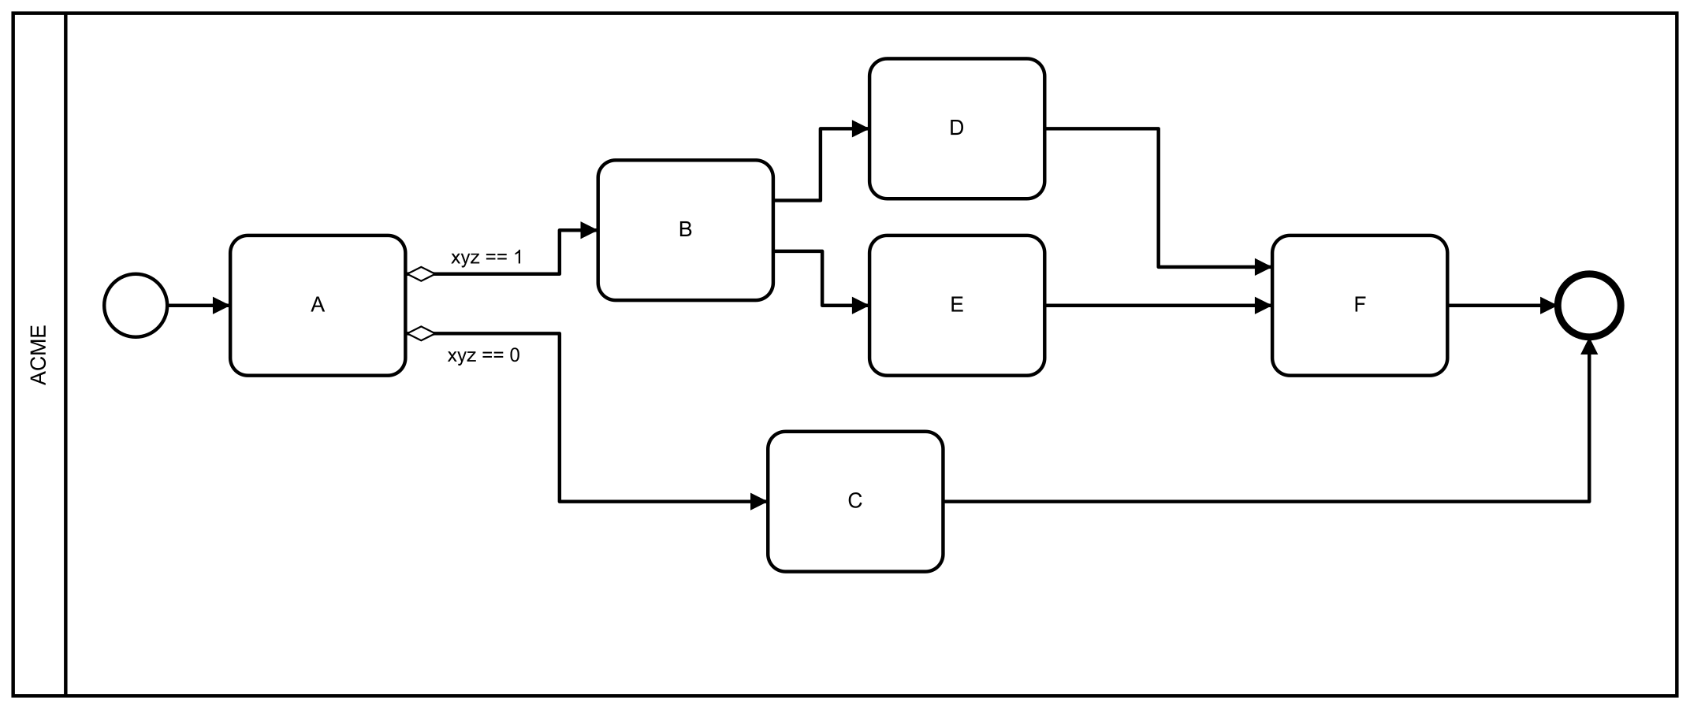
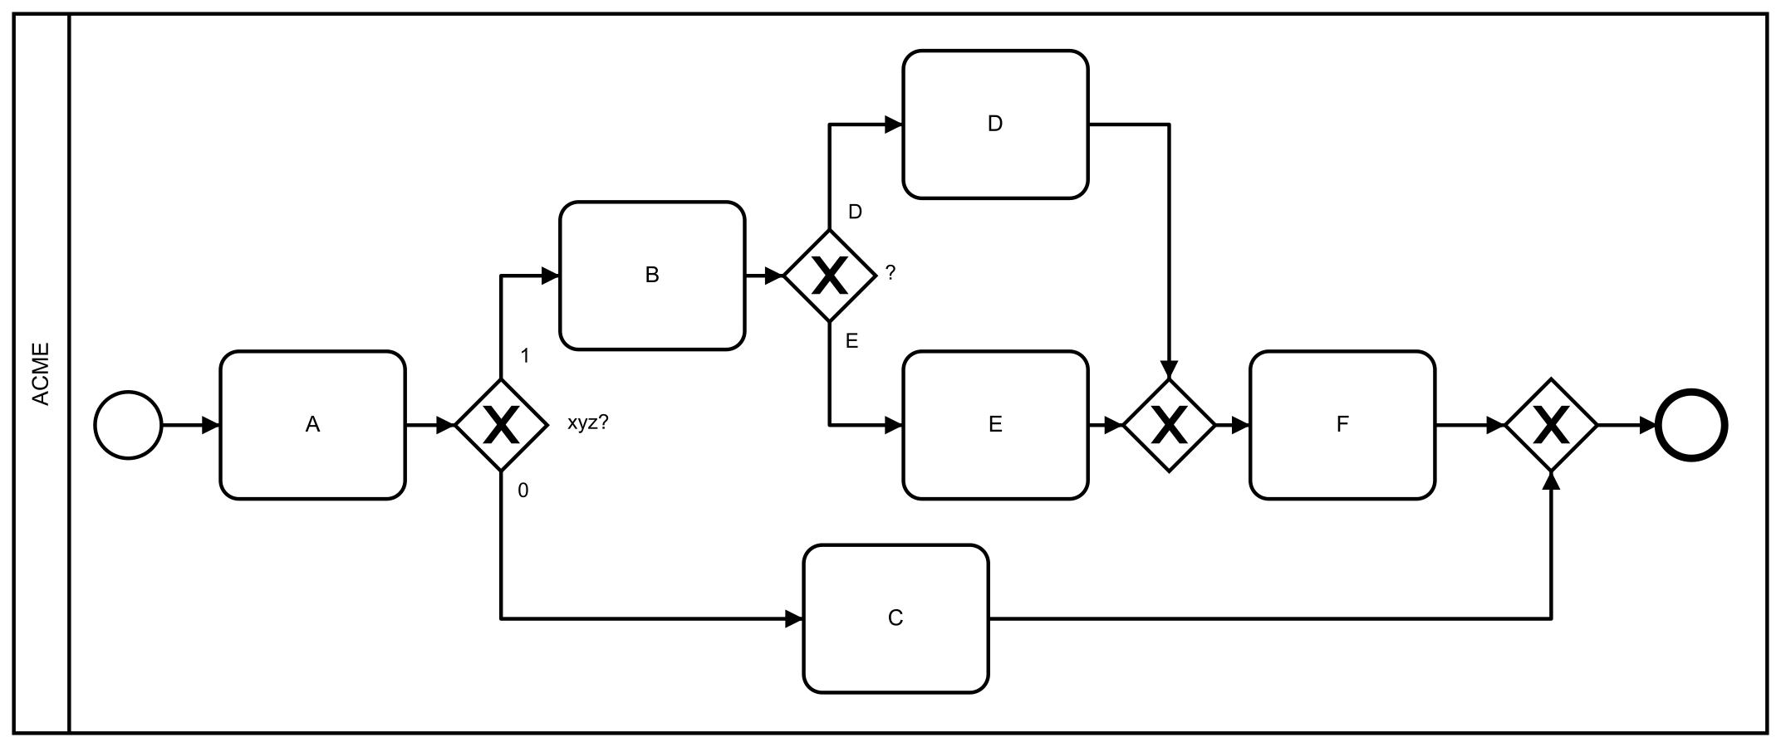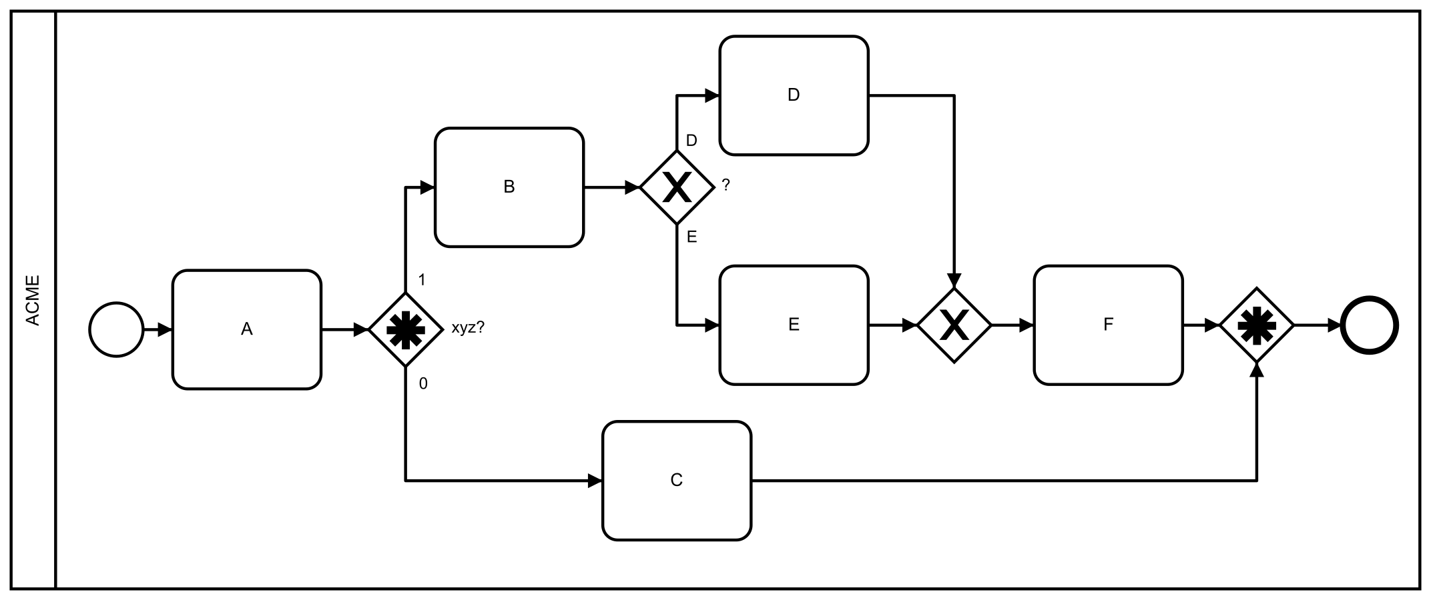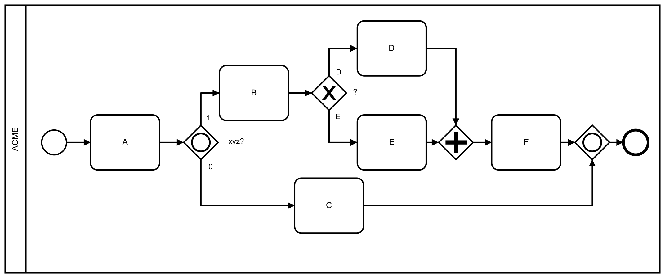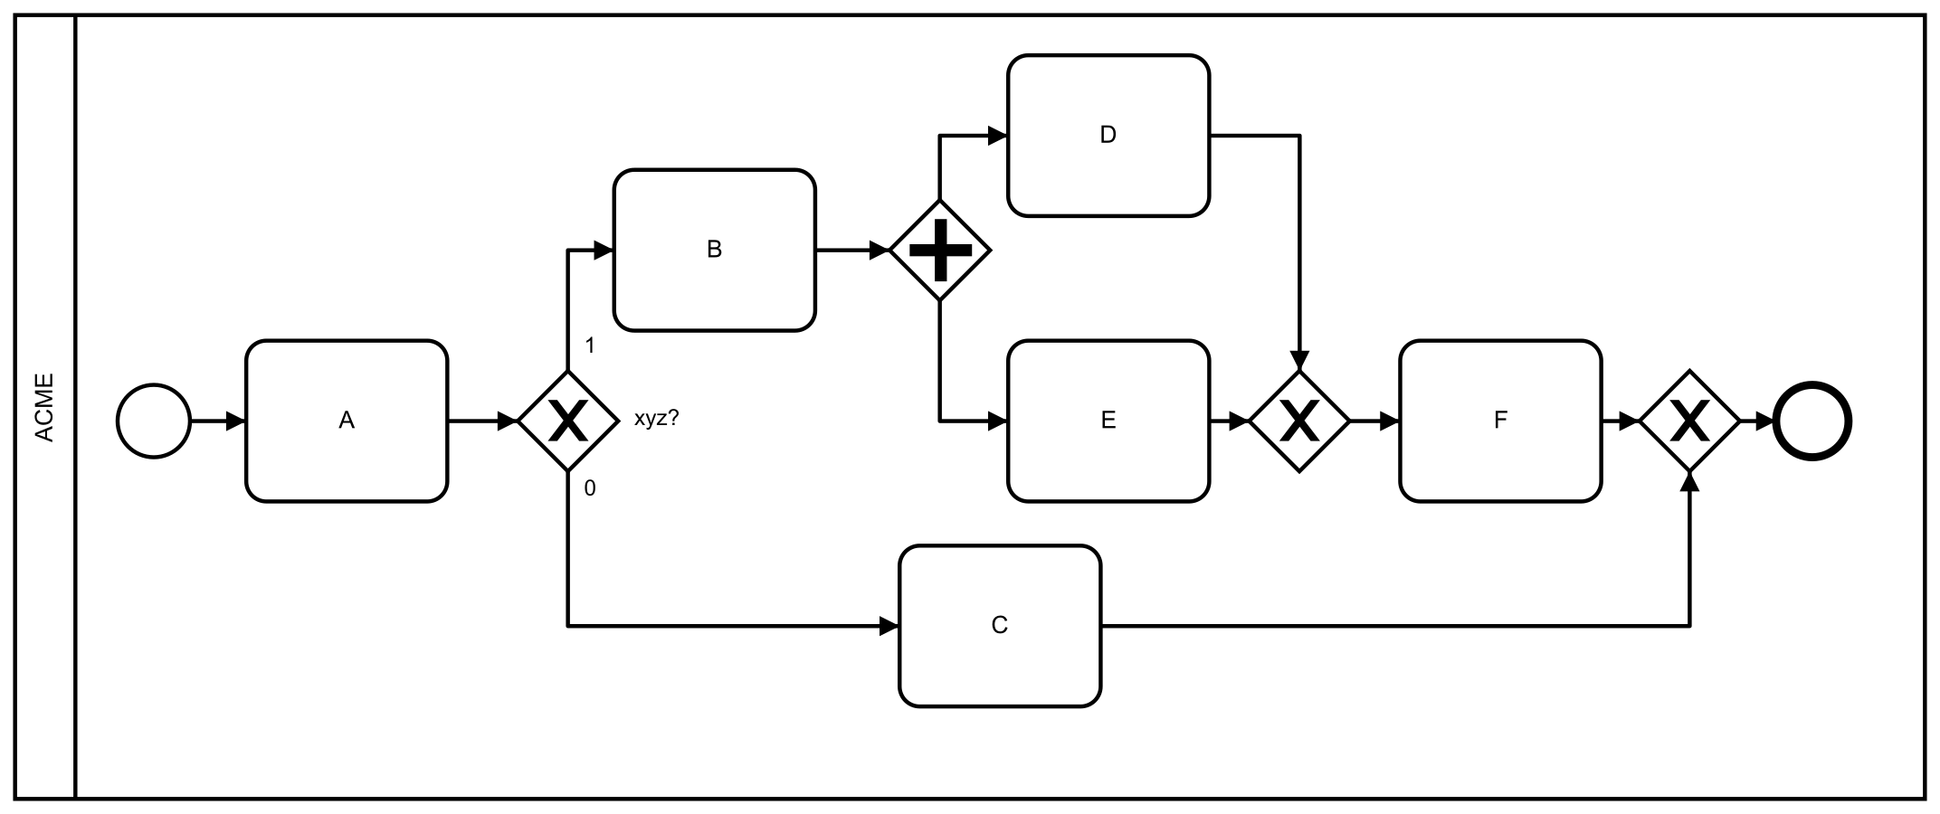
Multiple Choice
74)
In the following BPMN 2.0 diagram, which message flows are incorrect?
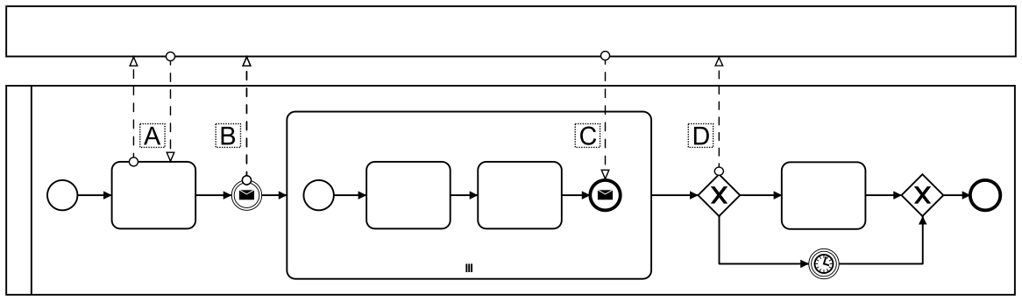
ABCD
Multiple Choice
75)
When will a reply be received from a REST call to start a process instance?
Immediately
When the process has reached its first wait state
Never, because the method is void
When the process has reached its first service task
Multiple Choice
76)
How many transactions are used to complete a process instance of this process definition, if no async is set?

1
3
4
5
6
Multiple Choice
77)
What can be accomplished by using the Spin API for complex objects?
Increase in engine performance
Better error handling
Give a simple UI to viewing and editing Java Objects

